|  |  |
| --- | --- |
|  | **프로그래밍 개론Ⅰ**  **Lab05** |
| **분반** | **01** |
| **학번** | **1515655** |
| **이름** | **임소희** |
| **제출일** | **2015년 10월 15일** |

**Exercise 2-6**

**Write a function setbits(x,p,n,y) that returns x with the n bits that begin at position p set to the rightmost n bits of y, leaving the other bits unchanged.**

#실행 결과 (capture) 및 설명

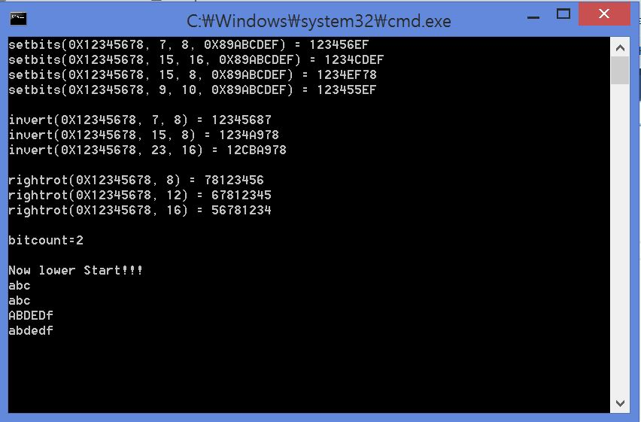

**(숙제) Exercise 2-7**

**Write a function invert(x,p,n) that returns x with the n bits that begin at position p inverted (i.e., 1 changed into 0 and vice versa), leaving the others unchanged.**

#실행 결과 (capture). 및 설명

**(숙제) Exercise 2-8**

**Write a function rightrot(x,n) that returns the value of the integer x rotated to the right by n positions.**

#실행 결과 (capture) 및 설명

**(숙제) Exercise 2-9**

**In a two's complement number system, x &= (x-1) deletes the rightmost 1-bit in x. Explain why. Use this observation to write a faster version of bitcount.**

#실행 결과 (capture) 및 설명

**(숙제) Exercise 2-10**

**Rewrite the function lower, which converts upper case letters to lower case, with a conditional expression instead of if-else.**

#실행 결과 (capture) 및 설명